**Experiment No. 1 Aim: Case Study on tool Countly**

**Theory:**

**Introduction:**

Countly is an open-source analytics and innovation platform designed to empower organizations with real-time insights into user behaviour across various digital platforms. Initially released in 2011, Countly has evolved into a feature-rich tool, allowing businesses to make informed decisions by analysing user data. With a commitment to open-source principles, Countly encourages collaboration, customization, and transparency in the field of analytics.Countly includes a server, a mobile SDK (for mobile analytics), or a web SDK (for web analytics), all of which you can freely use in your own company for your applications under the license terms.Countly API uses HTTP and a RESTful endpoint structure. Request and response payloads are formatted as JSON.Countly uses MongoDB engine to persistently store and retrieve analytics data. MongoDB is a leading NoSQL with JSON style documents, which fits great with both capabilities of Countly and serverside environment NodeJS

**Development Details:**

Countly is developed using a modern technology stack, primarily relying on JavaScript, Node.js, and MongoDB. This choice of technologies ensures a scalable and flexible platform that can adapt to the evolving needs of users. Dr. Abdulhakim Yuceer initiated the development, and over the years, a global community of developers has contributed to its growth. Countly's development is characterized by regular updates, bug fixes, and the incorporation of new features to enhance its functionality.Countly collects data from various sources, including mobile applications, web applications, and other digital platforms. It tracks user interactions, events, and other relevant data points. Security is a paramount concern in analytics platforms, especially when dealing with user data.

**Features:**

Countly offers a comprehensive set of features that cater to the analytical needs of businesses:

1. Real-time Analytics: Provides instantaneous insights into user interactions and behaviors, enabling organizations to react promptly to changing trends.
2. User Segmentation: Allows users to categorize their audience based on various criteria such as demographics, location, and behavior, facilitating targeted analysis.
3. Custom Dashboards: Users can create personalized dashboards to monitor and visualize the specific metrics that matter most to their business goals.
4. Push Notifications: Enables targeted messaging to users, helping organizations engage with their audience and drive user retention.
5. Plugin Architecture: Countly's extensible architecture supports plugins, allowing users to extend the platform's functionality or integrate third-party tools seamlessly.

**How to Use:**

Using Countly involves a structured process:

1. Installation: Follow the installation guides provided for different operating systems, whether on-premises or on cloud servers.
2. Configuration: Customize Countly by configuring data sources, integrating with applications, and adjusting settings to align with organizational requirements.
3. Dashboard Setup: Access the intuitive Countly dashboard to create custom views, set up user segmentation, and configure analytics parameters.
4. Integration: Utilize Countly's Software Development Kits (SDKs) for iOS, Android, and web platforms to seamlessly integrate analytics into mobile and web applications.

**Applications (Who can use it):**

Countly caters to a diverse range of industries and applications:

1. Mobile App Developers: Utilize Countly to track user behavior, optimize app performance, and enhance user experiences.
2. E-commerce: Analyze user journeys to improve conversions, personalize user experiences, and refine marketing strategies.
3. Media and Entertainment: Gain insights into content consumption patterns to tailor content recommendations and enhance user satisfaction.
4. Healthcare: Monitor patient engagement within health apps and analyze health-related data for better-informed decision-making.
5. IoT: Leverage Countly's support for IoT analytics to analyze data from connected devices and enhance IoT applications.

**Few Screenshots:**

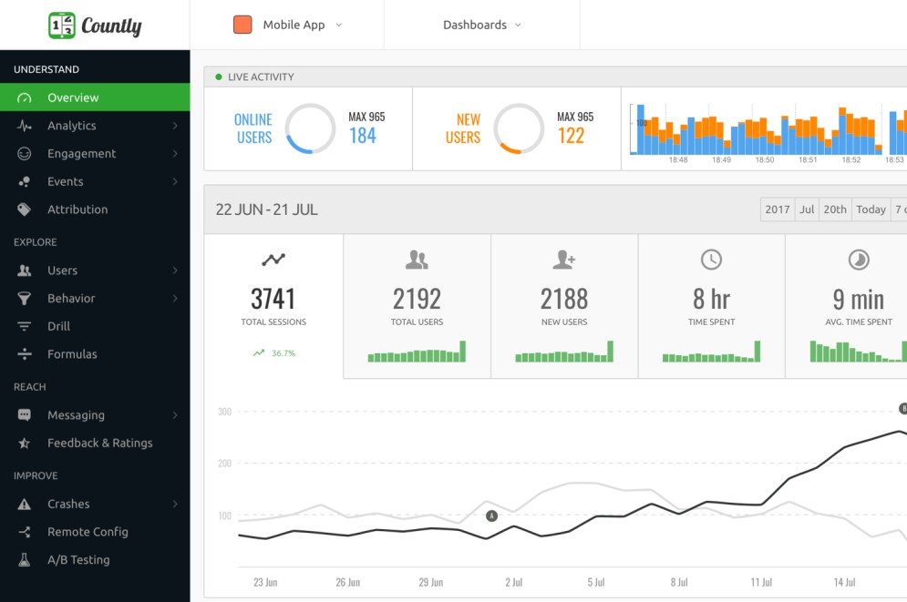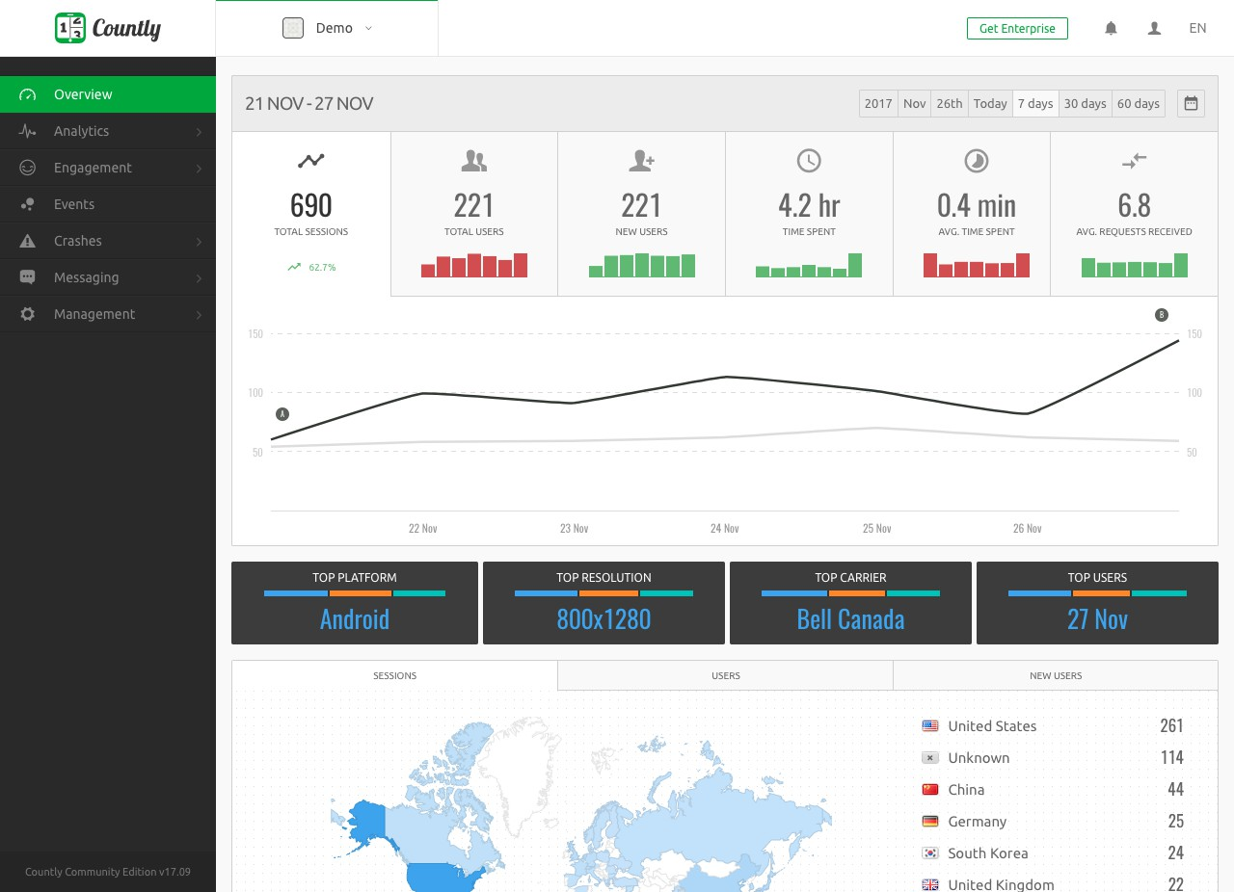

**Conclusion:**

Countly emerges as a robust and versatile open-source analytics platform that empowers organizations to harness the power of real-time user data. Its development details, rich feature set, and diverse applications make it a valuable asset for businesses across various industries. The open-source nature of Countly ensures adaptability, transparency, and continuous improvement through community collaboration. Organizations adopting Countly can leverage its features to gain actionable insights, optimize user experiences, and stay ahead in an ever-evolving digital landscape.